Update
November 2010 - Local Participation & Global Confidence – Te Ao Whanui
WOW! Term 4 already. A lot has happened since the June newsletter was written and there’s a lot more to come before the school year finishes.
Monday 14th June  Primary School 1-day Learning Retreat | A group of students from the class provided guidance and leadership at the Primary School 1-day Learning Retreat held at Edgecumbe Primary School. The Learning Retreat was based on the principles of the 2-3 day Retreat we hold each year for our Tuatahi students. Approximately 50 year 7 & 8 students attended from primary schools involved in the REAP Gifted & Talented Education programme. What an amazing day – 50 excited young children and not one behaviour problem or complaint about being bored! It proved that children who are actively involved in challenging learning activities have no time or desire to get into trouble.
E-pals  Edgecumbe – Thailand connection | Students who chose to support the learning of Burmese children living in refugee villages on the border of Thailand & Myanmar (was Burma) have been learning more about the living and educational needs of their E-pals. Communication is through interpreters so, despite being online, the conversations are few and far between. However, some of the Te Ao Whanui members have persisted and I have passed the letters on to the interpreter.  Although the EC students became involved in the project with the desire to assist the Burmese students with their English, they very quickly came to realise that the learning was two-way; the hopes and dreams of the Burmese children are largely around gaining the best education they can in order to be employed in work that will benefit others. You’ll be pleased to know that they emphasis respect and love for parents and teachers. See below for one of the profiles.
 | Hi. My name Pa Thom Porn Aintharuk and I am 13 years old girl. My birthday is 20.February/1997. I have three siblings. I live in Mai Lan village. My neighbour village call pang Kham village. There is no school in my village. I attend the school called Pang Kham school I am studying secondary 2. I have to walk down about 3 kilometers to the school every day. I love reading. I usually helping my parents work and doing my home work too. I want to be policewoman because I want to build unity in my community, arrest criminal and protect the country. In the school I like playing sport and doing activities with my friends such as going to the forest to learn the natural and visited other places. I have (7) close friends their name are Tarrikar, Png, Kanya, Sar, Sou, Oil and Aung Fa.
6th – 7th August  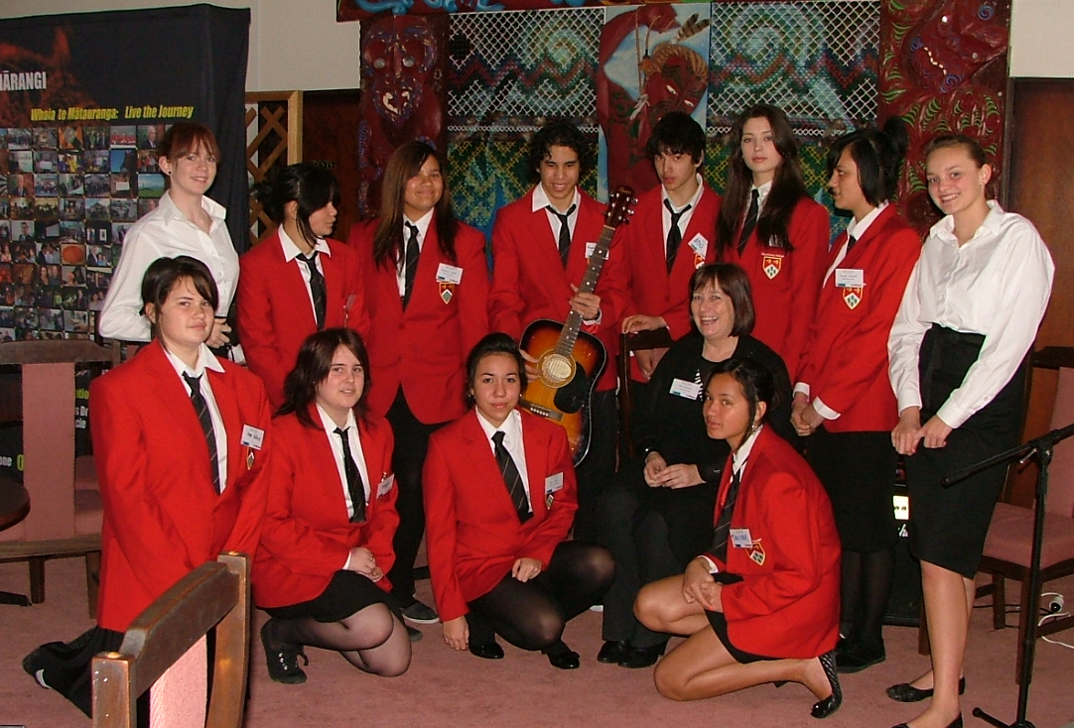 | Several students from the class were involved as hosts at a mini-conference held at Te Whare Wananga o Awanuiarangi on Friday 6th - Saturday 7th August and they impressed everybody! I was involved in my capacity as Adviser in Gifted Education. The theme of the conference was the Education of gifted and talented students in the Eastern Bay of Plenty, with a special focus on providing appropriately for Maori and rural students. Nationally and internationally acclaimed experts in this field presented at the conference alongside 2 teachers from Edgecumbe College. We have received several letters praising the behaviour and abilities of our students – they were stunning!
Saturday 21st August  Junior United Nations Model Debate | Mrs Moloney and I took 2 teams from the class to the Bay of Plenty Junior United Nations Model Debate held at Otumoetai College this year. The event started at 9a.m. and finished at approximately 4p.m. so it was an early start and a long day for all of us. Our students presented themselves (and the countries they were representing) very well and were active contributors to the two debates 1) Sport for Peace and Development, and 2) The Rights of Child Refugees. The topics are only known about a month in advance so the teams were fortunate that the second topic was one with which they were already very familiar.
Early Start to NCEA | 14 students from the class gained their Achievement Standard ‘Social Action Leading to Social Change’ – Yes, it was challenging for them but they persevered and achieved their goals. Of the 14 who achieved this standard, two students received Excellence grades and four received Merit grades. If they continue to study Level 1 Social Sciences in 2011, and receive a further 3 grades at merit or excellence, their NCEA certificates will be endorsed with Merit or Excellence – a significant achievement and very impressive in the CV.
Current Unit of work | Each member of the class has researched the life of an historical person who has made a positive contribution to history. As well as learning about the individual and his/her contribution students had to analyse the impact a powerful speech can have on society. The presentations have been well-researched and fascinating.
Inquiries | These should be almost ready for presentation. I’m very impressed with the range of interesting activities students have been involved in and the wonderful contribution they’re making to the community. Come along to the Presentation Evening on December 30th to see the results of their year-long Inquiries.
Opportunity: Te Ao Whanui students have been invited to participate in an online United Nations video-conference for secondary schools, on the topic of ‘A Global Response to Climate Change’ – live from Mexico, on 9/12/10, 8a.m. NZ time. Edgecumbe College is one of only four NZ schools participating.

